Multiple inheritance in java is not allowed

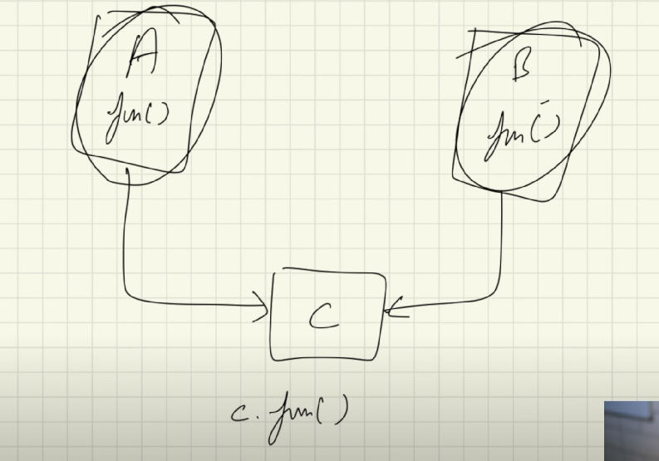

Here let say class C inherit for both class A and class B

And let say there is fun ( ) in both classes

Here on doing c.fun( ), java will get confused about which fun ( )are we trying to call

**Real world example**

In real life the parents tell their kids what to do, what to become, which career path to choose.

But they do not tell how to do?

So

A parent class that tells the child class what to do, but not how to do

It tells what things are to be done but it itself do not provide any implementation

Such class is abstract class

It shows provides only the functionality and do not provide any implementation details of that function

**Abstraction is a process of hiding the implementation details and showing only functionality to the user**

**Abstraction can be achieved with either abstract classes or interfaces in java**

So abstract classes provide abstraction in java

An abstract method must be present inside the abstract class and no where else, and it’s common sense also

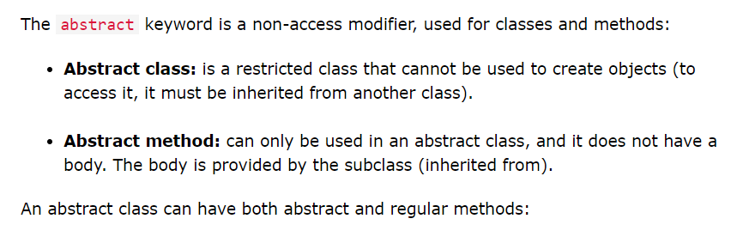

The abstract methods do not have function body, they are present only inside abstract classes

Objects can not be created from the abstract classes

An abstract class can only be inherited by child class, and the body to the function or implementation details for the abstract function defined inside the parent abstract class is provided in the child class via method overriding

It is the responsibility of the child class to provide the implementation details to the abstract methods defined inside the parent abstract class, via method overriding

So all the abstract methods of the parent class are overridden by the child class

We can have regular methods, static methods, abstract methods inside the abstract classes

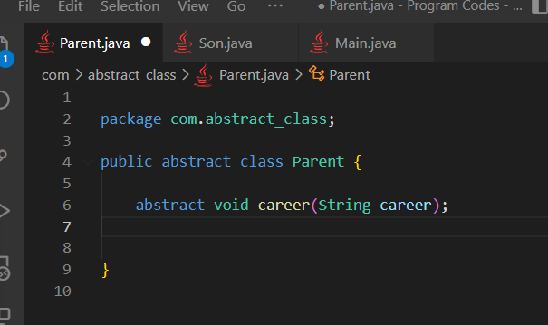

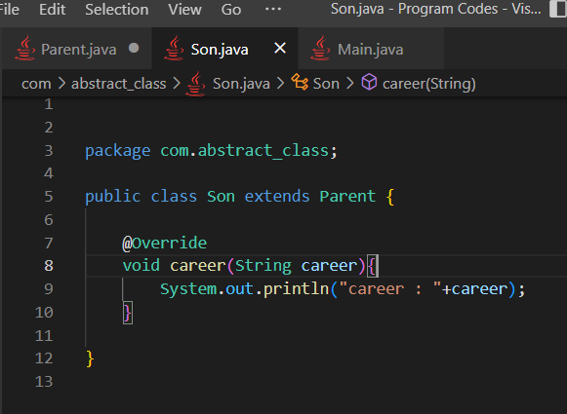

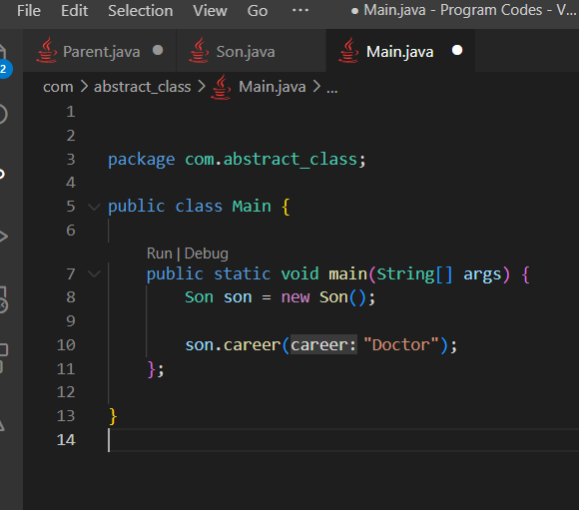

Here Parent abstract class contained an abstract method which was overridden by the Son child class

Also

we may also have constructor in the parent class, but we can not make any object of the parent class

That constructor may be called via child class using super( ) method

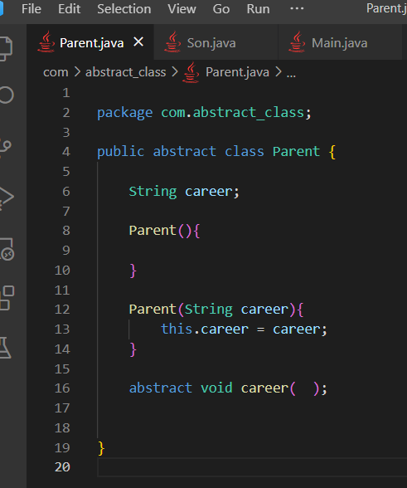

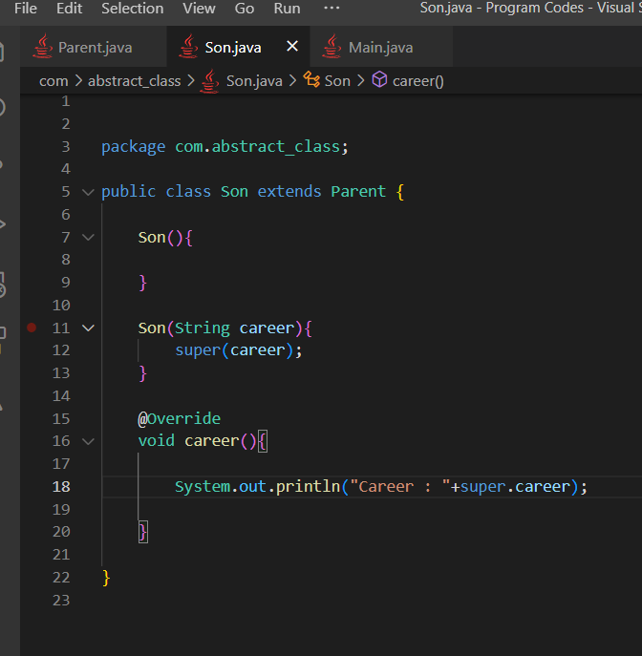



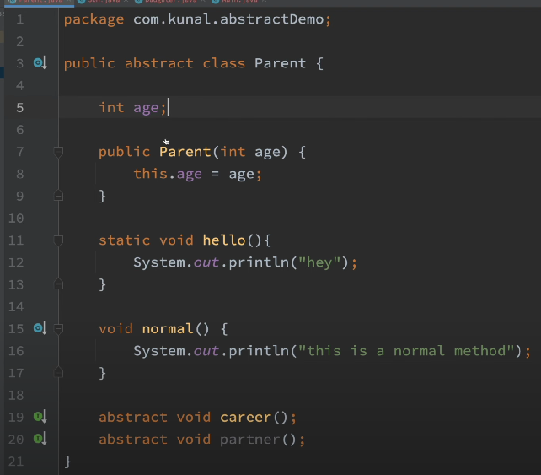

We can have normal variables, normal methods, and also the static methods inside the abstract classes

**But since static methods can not be overridden we can not have abstract static methods**

**Can we have final abstract method or final abstract class ?**

A final method can not be overridden and a final class can not be extended inherited

So it just doesnot make sense